**ASSIGNMENT - 2  
DBMS LAB**

**ROUNAK SAHA**

**IT - A3**

**002211001132**

**1.Display the Name, manager Id, and hire date of all employees who are either clerk or works in dept 20. the date should be in the following format: DATE_HIRED Seventeenth December, 1980 Second April, 1981**

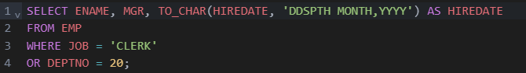

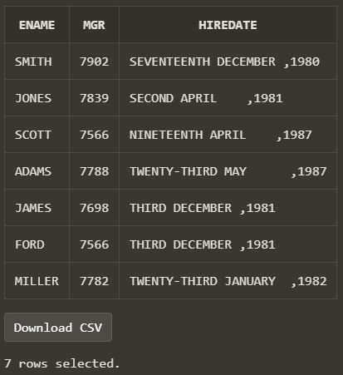

**2. List the employee name and old salary and new increased salary by 25% and expressed as a whole number.**



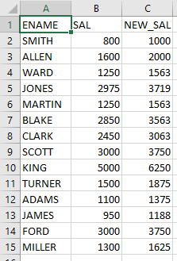

**3. List the employee name and salary where name is displayed as left justified and salary with right justified.**



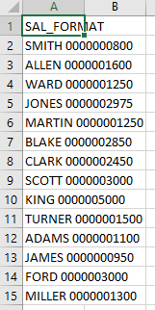

**4. Produce the output as follows(for all employees) ROLE OF THE EMPLOYEE Name1 () Name2 () ........ Note: Only first character of Name and job will be in uppercase.**



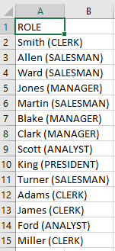

**5. Give the details of an employees with job is clerk (enter the job value clerk as input).**

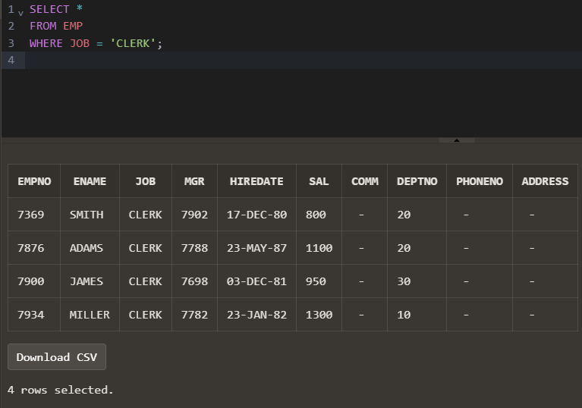

**6. Display each employee name with hiredate and salary review date. Assume that date is one year after hiredate. Order the output in ascending review date order.**

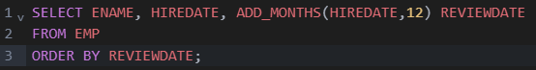

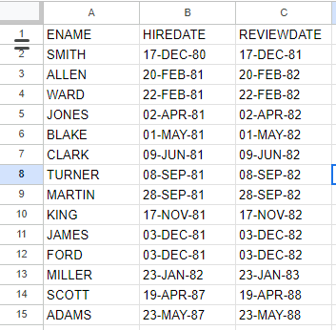

**7. Find the employees(s) who earn the highest salary in each job type sort in descending salary order(Use IN operator and subqueries)**

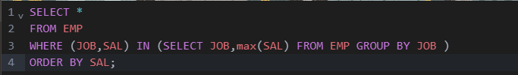

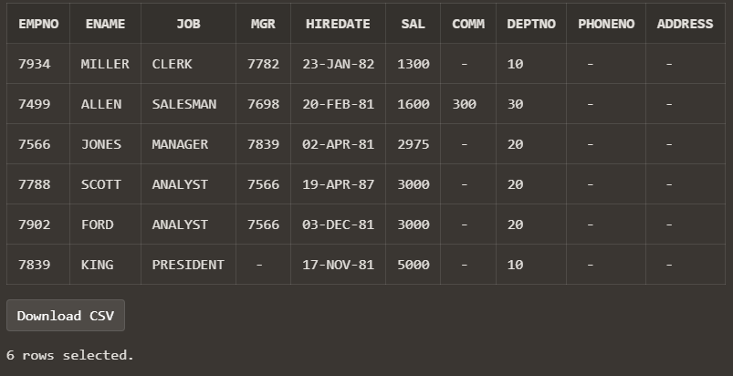

**8. Find the most recently hired employee in each department (give number only).**

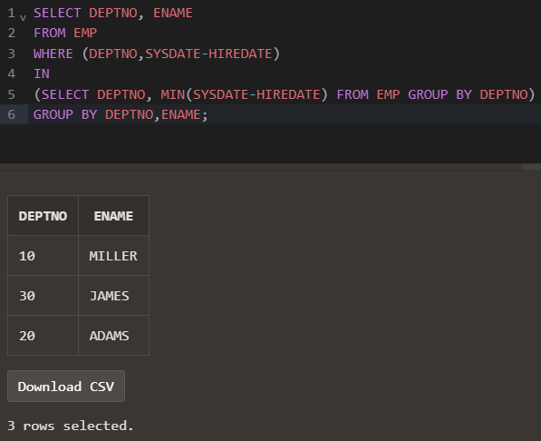

**9. Show the name of the department and no of employees who works in that department. Sort in department number.**

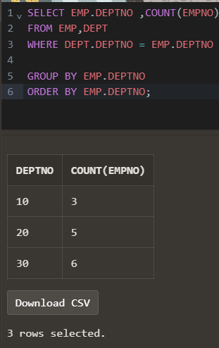

**10. Display the Id, name, salary and the salary grade for any employee who earns the maximum salary for their department. Sort in department number.**

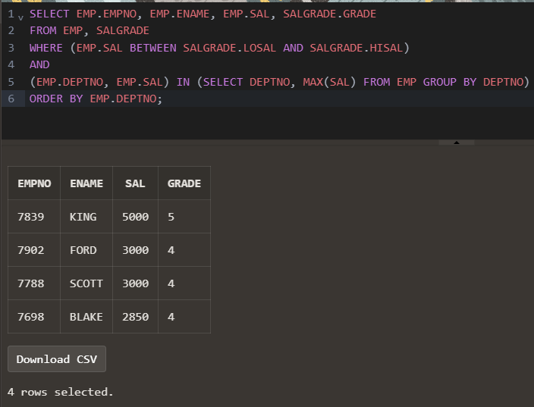

**11. In which year did most people join the company? Display the year and number of employees.**

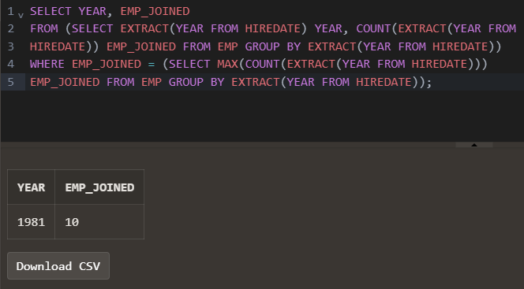

**12. Show the every alternate row in employee table.**

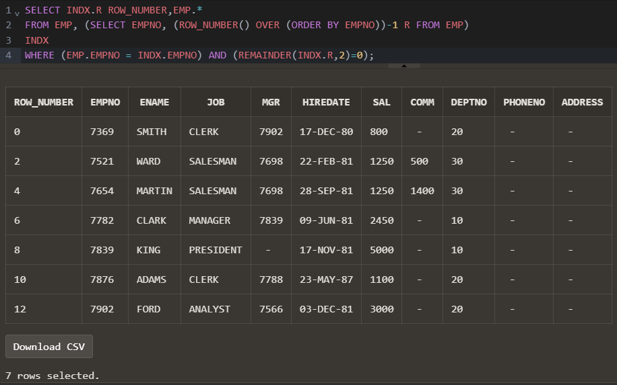

**13. Display the total salary of all employees. Total salary = salary + commission.**

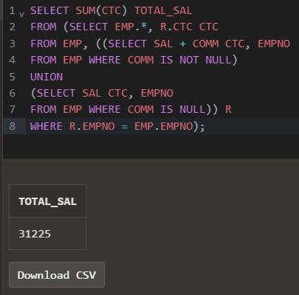

**14. Display the department name and available jobs in that department.**

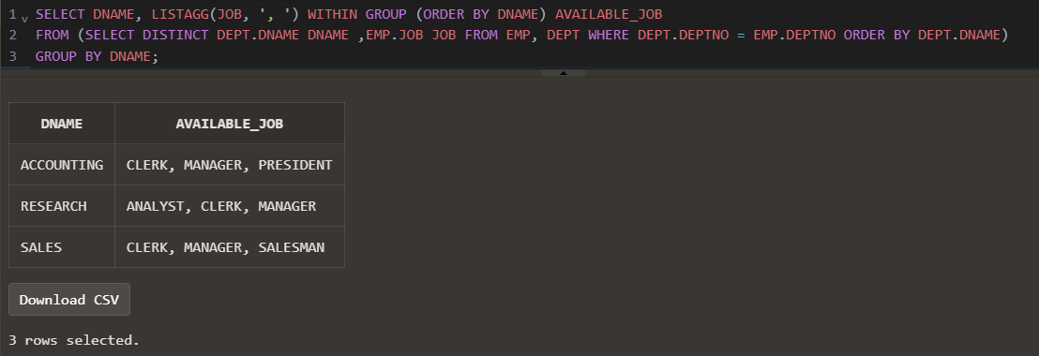

**15. Display all the available departments and the employee(s) works under it.**

